Scientific Name of First Article

First Author’s Name¹, Second Author’s Name² and Third Author’s Name³

- Company/University, Country. ^{2,3} Company/University, Country.

¹first author email, ²second author email, ³third author email

Received Month, Date, Year, Accepted: Month, Date, Year, Published Online: Month, Date, Year
Reviewers: Anonymous Peer Review
Citation: Author's Last Name, First Name, et al. "Title of Article." Title of Journal, vol. Volume, no. Issue, Month Year of publication, pp. Pages, https://doi.org/DOI.

Abstract

This document gives formatting instructions for authors preparing papers for publication in the said journal. The authors must follow the instructions given in the document for the papers to be published. You can use this document as both an instruction set and as a template into which you can type your own text. This abstract should be size 12, Times New Roman, and Bold.

Keywords: Include at least 5 keywords or phrases

- Introduction

When you submit your paper print it in single-column format, including figures, equations, and tables. When adding figures, and tables they should be centered. Equations should be left justified and indented. In addition, designate one author as the “corresponding author”. This is the author to whom proofs of the paper will be sent. Proofs are sent to the corresponding author only.

- Background

Your paper submission should follow this document exactly, including: Section titles (Intro, background, etc.), sizing, font, andmargins. The specifics of how the document is laid out are to be found listed below.

Set your page as Letter, width 8.5”, height 11” and margins as follows:

- Left Margin (1")

- Right Margin (1”)

- Top Margin (0.8")

- Bottom Margin (0.8")

- Problem Statement

All the font in the text should be Times New Roman, size 12. It is single spaced with an extra line in between the heading and the paragraph text. The title of the manuscript should be size 24, Bold, Times New Roman. The names of the authors are Times New Roman size 11, and the size of the university information and email addresses are size 10 Times New Roman. This can all be seen above.

- Approach

Place illustrations (figures, tables, drawings, and photographs) throughout the paper at the places where they are first discussed in the text, rather than at the end of the paper. Number illustrations sequentially (but number tables separately).

- Methodology

Place the illustration numbers and caption under the illustration in 10 pt font. Do not allow illustrations to extend into the margins. If your figure has two parts, include the labels “(a)” and “(b)”
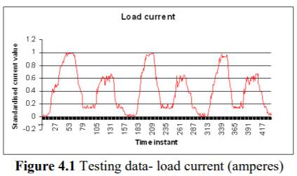

- Results

Place table titles above the table. If the table is small and can fit in one column of the page.
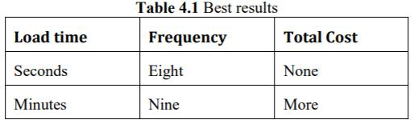

then it is okay. But if you have more number of columns, you can enlarge the table to fit the entire page.

- Conclusions

Number citations consecutively in square brackets [1]. The sentence punctuation follows the brackets [2]. Multiple references [2], [3] are each numbered with separate brackets [1]–[3]. Please note that the references at the end of this document are in MLA style. Please ensure that the provided references are complete with all the details and cited inside the manuscript (example: page numbers, year of publication, publisher’s name etc.,).

References

- MLA format

- MLA format

- MLA format

